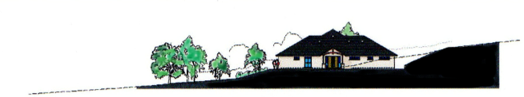

L A N G F O R D B U D V I L L E J U B I L E E H A L L

Registered Charity Number 287714

SCALE OF CHARGES

1 Jan 2023 to 31 Dec 2023

With the exception of the Wedding Package all rates are for one hour.
Main Hall: | Non local users | Local users
Monday - Friday 6.00pm | £12.50 | £10.50
Friday 6.00pm - Sunday midnight | £15.00 | £12.50
Committee Room: any time | £6.25 | £5.50
Kitchen: any time | £5.25 | £4.50
Private use of Village Hall: including all above rooms
Monday - Friday 6.00pm | £23.00 | £19.50
Friday 6.00pm - Sunday midnight | £25.00 | £21.50
SPECIAL PACKAGES:
Weddings:
Private use of Village Hall including all rooms as follows:  Wedding eve: 6.00pm - 9.00pm  Wedding day: 8.00am - 12.00 midnight  Following day clear up: 8.00am - 10.00am  Extra hours package  Wedding eve: 12.00 midday – 9.00pm  Wedding day: 8.00am – 12.00 midnight  Following day clear up: 8.00am – 12.00 midday | £435.00  £580.00 | £360.00  £490.00
Children's parties:
Use of Main Hall and Kitchen
Monday - Friday 4.00pm | £16.50 | £13.50
Friday 4.00pm - Sunday | £19.00 | £16.00

